PITTSBURG MUSEUM EVENTS & ACTIVITIES
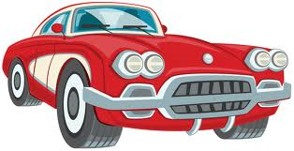
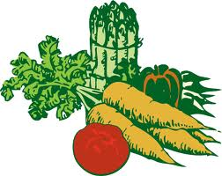
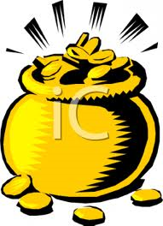
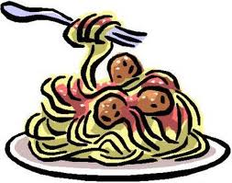


OLD TOWN PITTSBURG CAR SHOWS
Museum Will Be Open 6-8 Pm
Every Thursday Starting May 5th

PITTSBURG FARMERS’ MARKET
Saturdays, 9am-1pm Beginning May 7th
After The Market Visit The Museum
We Will Be Open

MEMBERSHIP APPRECIATION DAY
& Open House—Featuring
“Una Storia Segreta” Exhibit
Saturday, May 21st 1-5 Pm

POT OF GOLD RAFFLE TICKETS
$20 Each—Prizes $1000, $750, $500
Tickets Sold At Museum

3RD ANNUAL PASTA DINNER
Saturday, August 20th
Pittsburg Elks Lodge
Cost $25—Tickets On Sale June 1st

