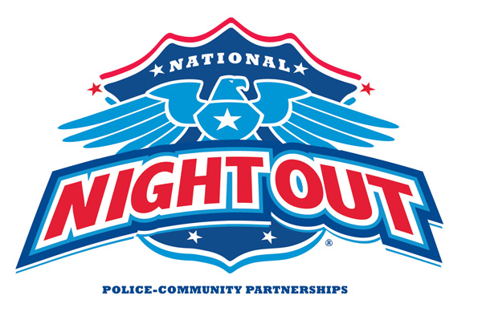

**Building Safer and Better Neighborhoods Through Community Involvement**

***Tuesday August 4th 2015***

***5:00pm to 8:00pm***

***FREE ADMISSION***

***Small World Park***

***2551 Harbor Street, Pittsburg***

***Rides, Jumpies, DJ & Music***

***Police Vehicles, SWAT Team***

***Police K-9’s and Motorcycles***

***Child Fingerprinting, Pony Rides***

***Free Safety information***

***FREE Hamburgers, Hot Dogs and Drinks!***