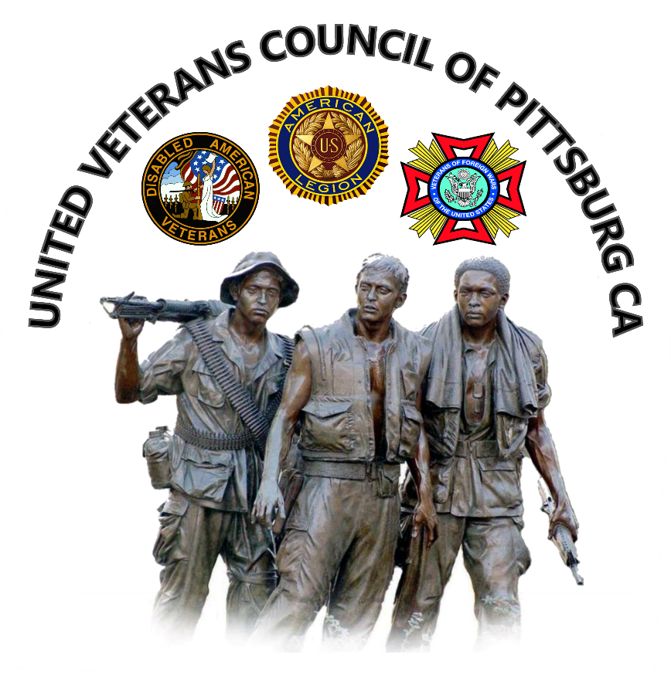

**The United Veterans Council**

**& the City of Pittsburg, CA  
  
Annual Veterans Day Ceremony**

Wednesday, November 11, 2015  
11:00 a.m.

Pittsburg Senior Center

300 Presidio Lane

Pittsburg, CA 94565

For further info contact:

***Ben Johnson***

Chairman of United Veterans Council

(925) 759-3444

[johnben31@comcast.net](mailto:johnben31@comcast.net)



***Wilfred Scott***

Vice Chairman of United Veterans Council

(925) 432-9252

[wjs17@comcast.net](mailto:wjs17@comcast.net)  
  
***Come early to enjoy a pancake breakfast served by Pittsburg Kiwanis. Served from 8-10 a.m..***