Friends of the Pittsburg Library

Members and Non-Members

 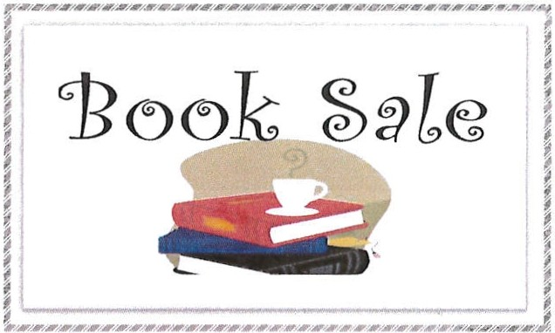 

Purchase a bag $4 Become a Member

Fill it up for free Enjoy extra savings

Fiction - Non-fiction - Cook Books – Travel  
Foreign Language - DVDs - CDs





Books for Children & Young Adults

**Dates:**

November 3 to November 7

Tuesday through Friday – 1 p.m. – 5 p.m.  
Saturday - 11a.m. - 5p.m.

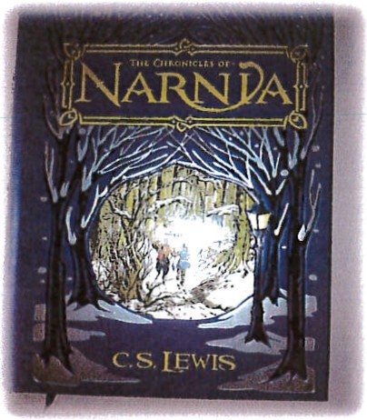

RAFFLE DRAWING: NOVEMBER 7,2015

CHRONICLES OF NARNIA  
LEATHER-BOUND EDITION

$90 VALUE

TICKETS $0.50 each or 3 for $1.00  
PURCHASE. TICKETS 11 /3 - 11/7  
during book sale hours

All proceeds benefit the Pittsburg Library by providing funds for library programs, new books, equipment, and special events.